**1.Introduction**

**1.1 Introduction**

In Body Shop Management Project we use Java & MySQL Database. This project keeps the record of all activities that happen in body shop such as managing inventory/stock, managing car wash, also managing the car denting.

In the dynamic world of automotive services, efficient management of body shops plays a pivotal role in customer satisfaction, operational effectiveness, and overall profitability. As vehicles become more complex and technologically advanced, the demands placed on body shop managers and their teams continue to evolve.

This project aims to delve into the intricacies of body shop management, focusing on the strategies, tools, and best practices that drive success in this specialized field. From streamlined repair processes to customer relationship management, every aspect of body shop operations will be explored to uncover insights that can enhance efficiency and service quality.

**1.2 Motivation**

The automotive industry stands at the forefront of technological advancement, constantly evolving to meet the demands of a dynamic market. Within this landscape, the management of body shops represents a crucial aspect that directly impacts the efficiency, profitability, and customer satisfaction levels of automotive repair businesses.

The motivation behind the development of a comprehensive Body Shop Management System stems from several key factors:

* **Increasing Complexity of Repairs**

Modern vehicles are equipped with sophisticated technologies, intricate designs, and advanced materials. As a result, the repair process for damages incurred in accidents or wear and tear has become significantly more complex. Body shop managers are tasked with overseeing repairs that involve not only traditional mechanical systems but also intricate electronic components and safety features such as airbags and sensors.

* **Demand for Streamlined Operations**

Efficiency is the cornerstone of success in any business, and this holds especially true for automotive repair shops. To remain competitive and meet the growing demand for quick turnaround times, body shops must streamline their operations. This includes effective scheduling of repairs, optimized workflow management, and seamless communication between technicians, customers, and suppliers.

* **Integration of Digital Tools**

In an era defined by digital transformation, the automotive industry is embracing a wide array of digital tools and software solutions. A Body Shop Management System aims to integrate these tools into a cohesive platform that simplifies tasks such as estimating, invoicing, parts ordering, and customer.

* **Focus on Customer Experience**

Customer satisfaction is paramount in the automotive repair business. A satisfied customer not only returns for future services but also becomes a brand advocate, spreading positive word-of-mouth. A Body Shop Management System enables body shop managers to provide a superior customer experience by offering transparent communication, accurate repair estimates, and timely updates on the status of their vehicles.

* **Data-Driven Decision Making**

In today's data-driven world, businesses of all sizes are leveraging analytics to make informed decisions. A Body Shop Management System collects and analyzes data on various aspects of the repair process, including turnaround times, inventory levels, employee productivity, and customer feedback. This valuable information empowers managers to identify areas for improvement, allocate resources efficiently, and make strategic decisions that drive business growth.

**1.3 Problem Statement**

* **Complex Repair Processes**

Modern vehicles are equipped with advanced technologies, including intricate electronic systems and safety features. Body shop technicians often struggle with accessing accurate repair information, resulting in longer repair times and potential errors.

* **Inefficient Workflow Management**

Manual processes for scheduling appointments, managing inventory, ordering parts, and tracking repair progress lead to inefficiencies and delays. This results in longer turnaround times, dissatisfied customers, and decreased revenue.

* **Limited Digital Integration**

Many body shops still rely on paper-based systems for estimates, invoices, and customer communications. The lack of digital integration hampers productivity, customer convenience, and the ability to analyze key performance metrics.

* **Poor Customer Communication**

Customers expect transparency and timely updates throughout the repair process. However, manual communication methods often lead to misunderstandings, delays in approvals, and dissatisfaction.

* **Increased Repair Times**

The lack of access to accurate repair information and inefficient workflow management contribute to longer repair times.

* 1. **Objective & Goals**

1. **Objectives**

* **Streamline Repair Processes**

Implement a user-friendly interface that provides technicians with easy access to repair manuals, diagnostic tools, and parts ordering systems.

Reduce repair times through efficient workflow management and optimized repair procedures.

* **Enhance Operational Efficiency**

Automate appointment scheduling, inventory tracking, and repair progress updates to minimize downtime and maximize productivity.

Improve resource allocation by providing real-time insights into technician availability, workload distribution, and equipment usage.

* **Integrate Digital Solutions**

Develop a system that allows for electronic estimates, online appointment scheduling, and digital invoicing.

Provide a centralized platform for customer communications, including automated updates, service reminders, and feedback collection.

* **Improve Customer Experience**

Enhance transparency throughout the repair process with automated updates, digital approvals, and online access to repair status.

Offer convenient communication channels for customers to inquire about repairs, approve services, and provide feedback.

**Goals**

1. **Optimize Repair Efficiency**

* Reduce average repair times by 20% within the first year of implementing the BSMS.
* Increase the number of repairs completed per technician by 15% through streamlined processes and improved resource utilization.

1. **Enhance Customer Satisfaction**

* Achieve a customer satisfaction rating of 90% or higher based on post-service surveys.
* Reduce customer complaints related to communication and repair delays by 30% within the first six months.

1. **Improve Revenue Generation**

* Increase overall revenue by 25% through upselling of additional services and improved pricing accuracy.
* Expand customer base by 20% through enhanced online presence, marketing, and positive customer reviews.

1. **Ensure Regulatory Compliance**

* Achieve full compliance with industry regulations and standards, with zero instances of non-compliance or penalties.
* Maintain accurate and up-to-date documentation of repairs, warranties, and certifications for audit purposes.

1. **Enhance Technician Productivity**

* Improve technician utilization rates by 15% through optimized scheduling and workload distribution.
* Reduce idle time by 20% through real-time monitoring and adjustments to workflow processes.
  1. **Scope & Limitation**

1. **Repair Management**

Track and manage all repair orders, including customer details, vehicle information, labor hours, and parts used.

1. **Inventory Control**

Monitor and update inventory levels in real-time, automate reordering of parts, and track supplier information.

1. **Appointment Scheduling**

Allow customers to book appointments online, view available slots, and receive automated reminders.

1. **Integration Challenges**

The integration of the new system with existing legacy software or hardware may pose compatibility issues.

1. **Customization Complexity**

Extensive customization requests beyond the defined scope may require additional time and resources.

1. **Budget and Resource Constraints**

Limited availability of IT resources or technical expertise could affect the speed of development and implementation.

**2. System Analysis**

**Existing System**

The Existing system contains following:

* **Point of Sales(POS):**

POS system that allows customer to make payments but there was no track of income and expenses.

* **Static :**

The user can view only the available services.

* **Basic Design:**

The website has simple level and user fid it hard to use.

* **Don’t have product functionality:**

The user can view the cars only not any information regarding it.

**Proposed System**

Following systems can be proposed in the existing system:

* **Customer Registration and Profile Management:**

Customers details can be registered, view their service history, and update there personal information.

* **Service Request Management**:

Customers service requests can be created, specify issues, and schedule appointments.

* **Inventory Control:**

Monitoring and updating of stock levels, low level can be identified and can be tracked.

* **Employee Profiles and Scheduling:**

Employee details, work schedules, and task assignments.

* **Scheduling appointments.**
  1. **Scope & Limitation of existing system**

1. **Integration with Digital Tools**

* **Estimating Software**

Integrate with industry-standard estimating software for accurate repair cost calculations.

* **Parts Ordering Systems**

Connect with suppliers' systems for seamless ordering, pricing updates, and parts availability checks.

* **Customer Relationship Management (CRM)**

Sync customer data, preferences, and service histories for personalized interactions.

* **Online Portal for Customers**

Provide a user-friendly portal for customers to view repair status, approve work, and make payments.

1. **Managing Workflow**

* **Washing Records**

Stores all vehicles details those are currently lined up for washing.

* **Denting Management**

This business plays important role in body shop as by assessing vehicle condition we can estimate the time for work on the car.

* **Ancilaries**

We can also manage stock on this software and do purchase sell of stock from here.

1. **User Training and Support**

* Offer comprehensive training sessions for body shop staff on using the new system effectively.

1. **Integration Challenges**

* The integration of the new system with existing legacy software or hardware may pose compatibility issues.
* Limited availability or compatibility of APIs from third-party software providers could hinder seamless integration.

1. **Customization Complexity**

* Extensive customization requests beyond the defined scope may require additional time and resources.
* Customizations could impact system stability, scalability, and future updates.

1. **Budget and Resource Constraints**

* Budget limitations may restrict the inclusion of certain advanced features or modules.
* Limited availability of IT resources or technical expertise could affect the speed of development and implementation.

1. **Data Migration Challenges**

* Transferring existing data from legacy systems to the new BSMS may require careful planning and execution.
* Data inconsistencies or errors in the migration process could affect the accuracy of records in the new system.
  1. **Project Perspective**

The "Body Shop Management System" project aims to modernize and optimize the operations of automotive repair shops, specifically focusing on body repair processes. By leveraging technology and digital tools, the project seeks to enhance efficiency, improve customer satisfaction, and drive profitability for body shops of varying sizes. The system will provide a centralized platform for managing repair orders, inventory, appointments, customer communications, billing, and reporting. The perspective of this project is to create a user-friendly, integrated, and data-driven solution that empowers body shop owners, managers, and technicians to streamline their operations, increase productivity, and deliver exceptional service to their customers.

**2.4 Stakeholder**

1. **Body Shop Owners**

Role: They are the primary decision-makers and ultimate beneficiaries of the system.

Interests: Increasing operational efficiency.

Improving customer satisfaction and loyalty.

Maximizing profitability through optimized processes.

1. **Body Shop Managers**

Role: Responsible for overseeing day-to-day operations and ensuring smooth implementation of the system.

Interests: Streamlining repair processes to reduce turnaround times.

Optimizing resource allocation and workflow management.

Accessing real-time data for informed decision-making.

1. **Technicians and Repair Staff**

Role: Directly involved in carrying out vehicle repairs and using the system on a daily basis.

Interests: Easy access to repair orders, diagnostic information, and repair.

Efficient parts ordering and inventory management.

Mobile compatibility for on-the-go updates and job assignments.

1. **Customers**

Role: Seek repair services from the body shop and interact with the system for appointments, updates, and approvals.

Interests: Convenient appointment scheduling and reminders.

Transparent communication on repair progress and estimated.

1. **Suppliers**

Role: Provide parts, materials, and services to the body shop.

Interests: Streamlined ordering processes and automated notifications.

Integration with their systems for efficient order processing.

* 1. **Requirement Analysis**

|  |  |
| --- | --- |
| **Language** | Java |
| **Frontend** | Swing |
| **Database** | MySQL |

|  |  |
| --- | --- |
| **Hardware** | **Client** |
| **Processor** | Pentium 1.30Ghz or equivalent |
| **Operating**  **System** | * Microsoft Windows Vista * Microsoft Windows XP Home edition |
| **Memory** | 512MB for both Microsoft Windows Vista and Windows XP Home edition |
| **Hard Disk** | 40GB or Larger |

1. **System Design**

**3.1.1 E-R Diagram -**

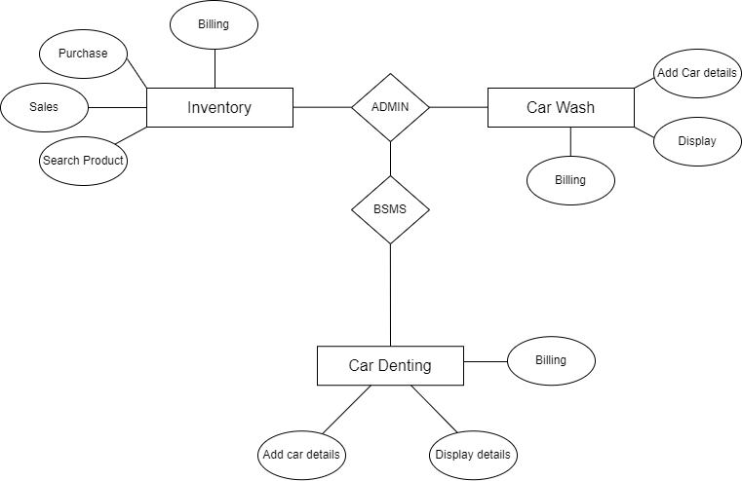

**3.1.2 Context Level Diagram -**

Context Level Diagram is also known as a **0-level DFD**. This is the highest-level DFD, which provides an overview of the entire system. It shows the major processes, data flows, and data stores in the system, without providing any details about the internal workings of these processes.

It’s designed to be an abstraction view, showing the system as a single process with its relationship to external entities. It represents the entire system as a single bubble with input and output data indicated by incoming/outgoing arrows.

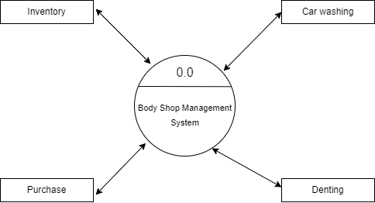

**Context Level Diagram (Level 0 DFD)**

**3.1.3 Data Flow Diagram**

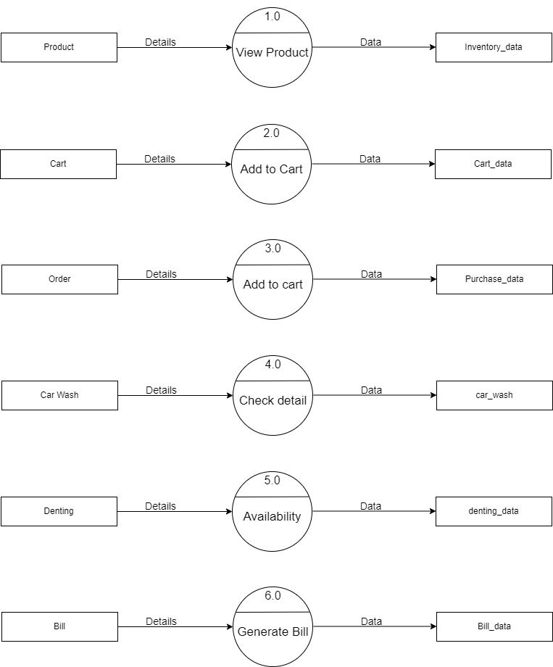

**3.1.4 Class Diagram**

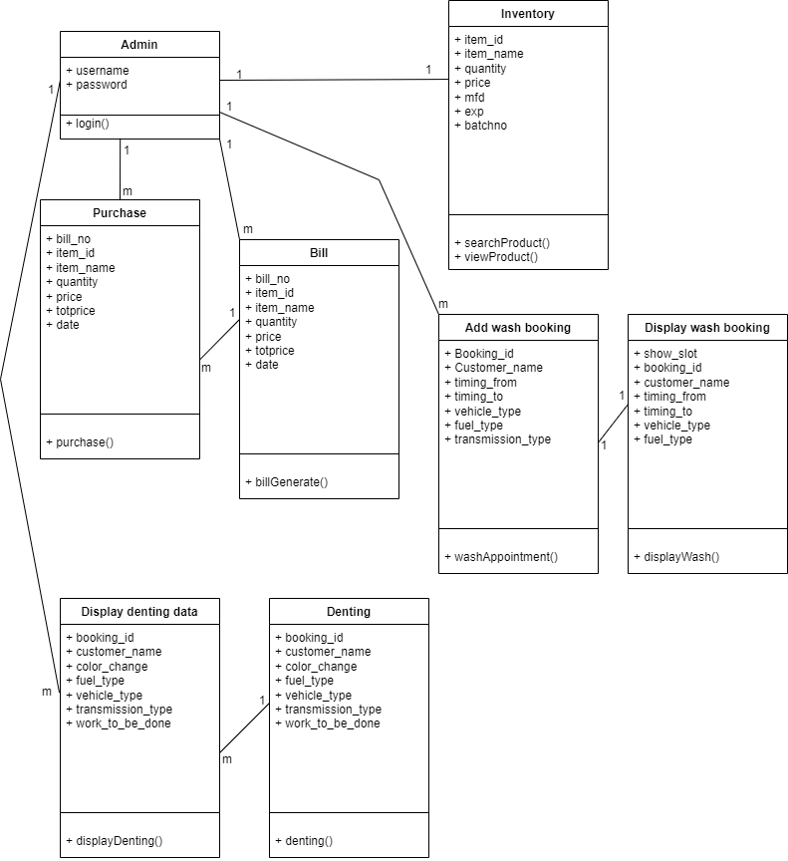

**3.1.5 Object Diagram**

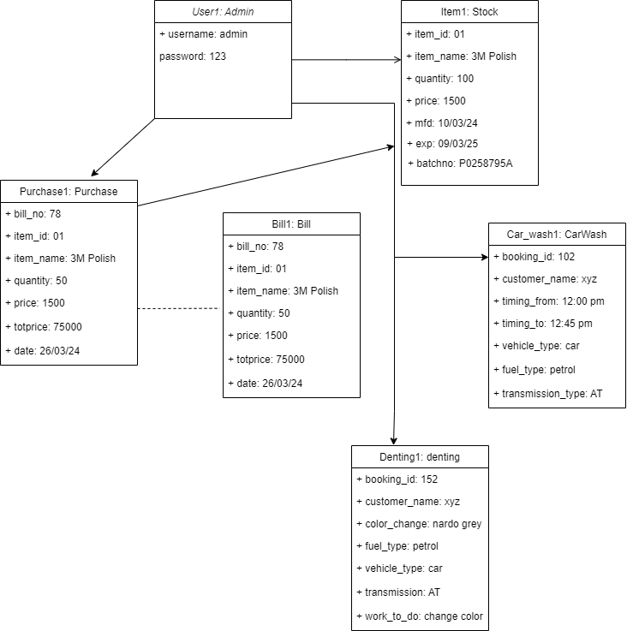

**3.1.6 Activity Diagram**

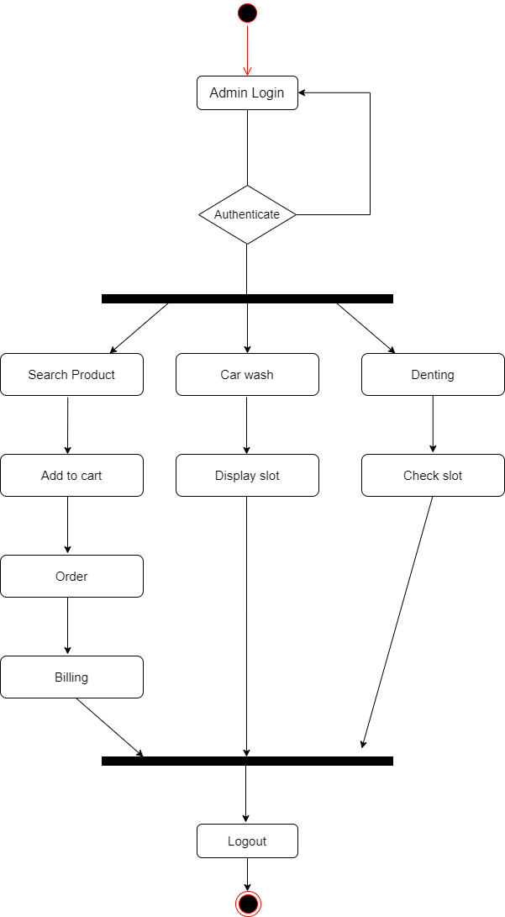

**3.4 Data Model –**

* Inventory:-

These are the body shop product details.

**Table Name:** inventory

|  |  |  |  |  |
| --- | --- | --- | --- | --- |
| **Sr no** | **Field Name** | **Type** | **Size** | **Constraint** |
| 1 | item_id | varchar | 10 | Primary key |
| 2 | item_name | varchar | 100 | NA |
| 3 | quantity | int | 100 | NA |
| 4 | price | int | 300 | NA |
| 5 | mfd | varchar | 300 | NA |
| 6 | exp | varchar | 10 | NA |
| 7 | batchno | varchar | 300 | NA |

* Cart:-

This stores the item added to cart.

**Table Name:** cart

|  |  |  |  |  |
| --- | --- | --- | --- | --- |
| **Sr no** | **Field Name** | **Type** | **Size** | **Constraint** |
| 1 | item_id | varchar | 30 | Primary key |
| 2 | item_name | varchar | 200 | NA |
| 3 | quantity | int | 100 | NA |
| 4 | price | int | 300 | NA |
| 5 | totprice | int | 11 | NA |

* Purchase:-

This stores the details about order executed by the user

**Table Name:** purchase

|  |  |  |  |  |
| --- | --- | --- | --- | --- |
| **Sr no** | **Field Name** | **Type** | **Size** | **Constraint** |
| 1 | item_id | varchar | 30 | Primary key |
| 2 | item_name | varchar | 200 | NA |
| 3 | quantity | int | 100 | NA |
| 4 | price | int | 300 | NA |
| 5 | totprice | int | 11 | NA |

* Bill:-

This stores the details of products which are added in cart and billed.

**Table Name:** bill

|  |  |  |  |  |
| --- | --- | --- | --- | --- |
| **Sr no** | **Field Name** | **Type** | **Size** | **Constraint** |
| 1 | billno | int | 30 | Primary key |
| 2 | item_id | varchar | 30 | NA |
| 3 | item_name | varchar | 200 | NA |
| 4 | quantity | int | 100 | NA |
| 5 | price | int | 300 | NA |
| 6 | totprice | int | 11 | NA |
| 7 | date | timestamp | NA | NA |

* Wash:-

This stores the details of all the vehicle which are in workshop for wash.

**Table Name:** wash

|  |  |  |  |  |
| --- | --- | --- | --- | --- |
| **Sr no** | **Field Name** | **Type** | **Size** | **Constraint** |
| 1 | cid | int | 11 | Primary key |
| 2 | c_name | varchar | 255 | NA |
| 3 | t_from | time | NA | NA |
| 4 | t_to | time | NA | NA |
| 5 | v_type | varchar | 255 | NA |
| 6 | f_type | varchar | 255 | NA |
| 7 | trans_type | varchar | 200 | NA |

* Dent:-

This stores the detail of all vehicle which are there for color change.

|  |  |  |  |  |
| --- | --- | --- | --- | --- |
| **Sr no** | **Field Name** | **Type** | **Size** | **Constraint** |
| 1 | cid | int | 11 | Primary key |
| 2 | c_name | varchar | 255 | NA |
| 3 | vehicle_type | varchar | 200 | NA |
| 4 | fuel_type | varchar | 200 | NA |
| 5 | work_to_do | varchar | 255 | NA |

|  |  |  |  |  |
| --- | --- | --- | --- | --- |
| **Sr no** | **Field name** | **Type** | **Size** | **Description** |
| 1 | item_id | varchar | 10 | Product Id |
| 2 | item_name | varchar | 100 | Product Name |
| 3 | quantity | int | 100 | Product Quantity |
| 4 | price | int | 300 | Product Price |
| 5 | mfd | varchar | 300 | Manufacture Date |
| 6 | exp | varchar | 10 | Expiry Date |
| 7 | batchno | varchar | 300 | Batch No |
| 1 | item_id | varchar | 30 | Product Id |
| 2 | item_name | varchar | 200 | Product Name |
| 3 | quantity | int | 100 | Product Quantity |
| 4 | price | int | 300 | Product Price |
| 5 | totprice | int | 11 | Total Price |
| 13 | billno | int | 30 | Bill No |
| 14 | item_id | varchar | 30 | Product Id |
| 15 | item_name | varchar | 200 | Product Name |
| 16 | quantity | int | 100 | Product Quantity |
| 17 | price | int | 300 | Product Price |
| 18 | totprice | int | 11 | Total Price |
| 19 | date | date | timestamp | Date |
| 20 | billno | int | 30 | Bill No |
| 21 | item_id | varchar | 30 | Product Id |
| 22 | item_name | varchar | 200 | Product Name |
| 23 | quantity | int | 100 | Product Quantity |
| 24 | price | int | 300 | Product Price |
| 25 | totprice | int | 11 | Total Price |
| 26 | cid | int | 100 | Customer id |
| 27 | c_name | varchar | 200 | Customer Name |
| 28 | timing_from | timestamp | NA | Timing for service |
| 29 | timing_to | timestamp | NA | Timing for service |
| 30 | car_type | varchar | 200 | Vehicle type |
| 31 | fuel_type | varchar | 200 | Fuel type of vehicle |
| 32 | trans_type | varchar | 200 | Transmission type |
| 33 | cid | int | 100 | Customer id |
| 34 | c_name | varchar | 200 | Customer Name |
| 35 | car_type | varchar | 200 | Vehicle type |
| 36 | fuel_type | varchar | 200 | Fuel type of vehicle |
| 37 | trans_type | varchar | 200 | Transmission type |
| 38 | work_to_do | varchar | 200 | Work to be done on car |

**3.5 Data Dictionary**

**3.6 User Interface (Input & Output Screen)**

* **Login Screen**

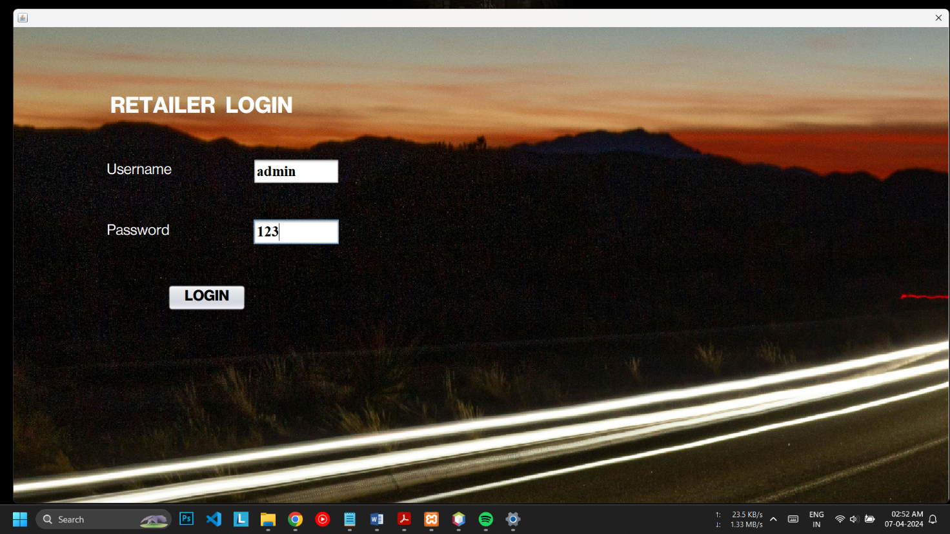

* **Home Screen**

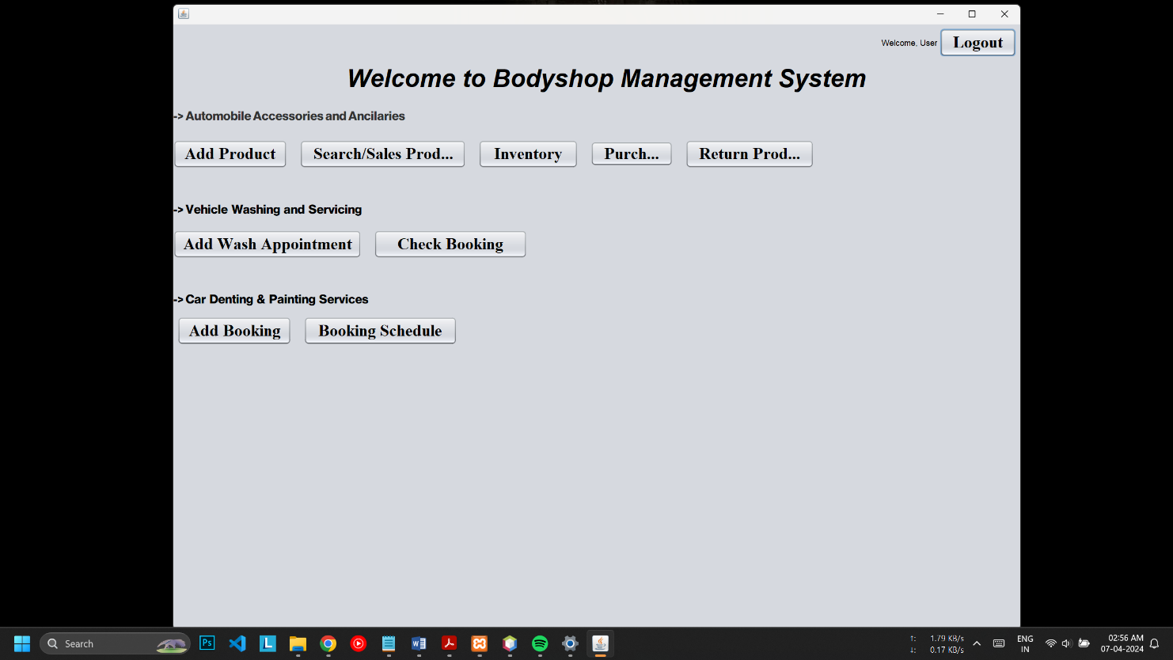

* **Add Product Screen**

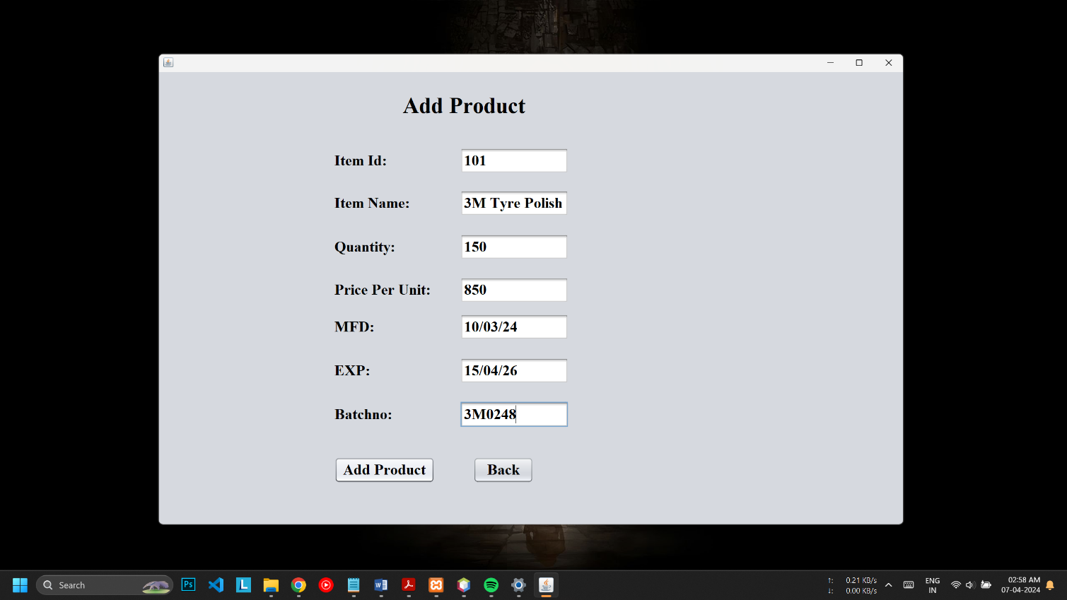

* **Inventory Screen**

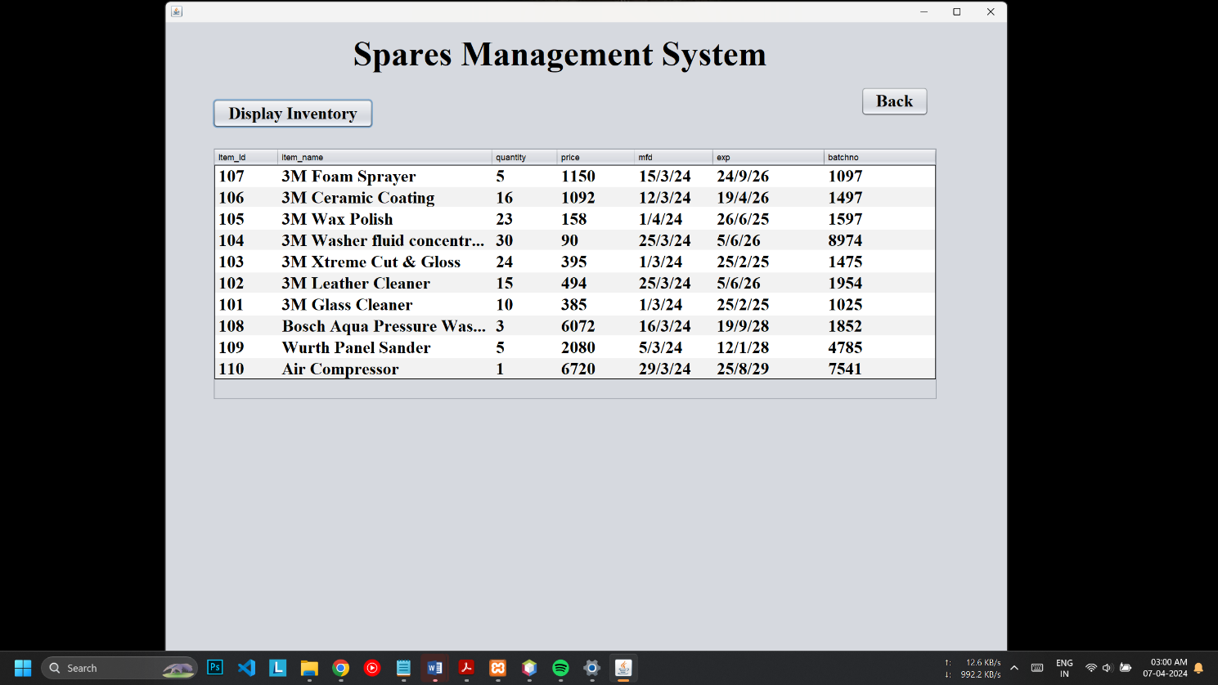

* **Product Manage Screen**

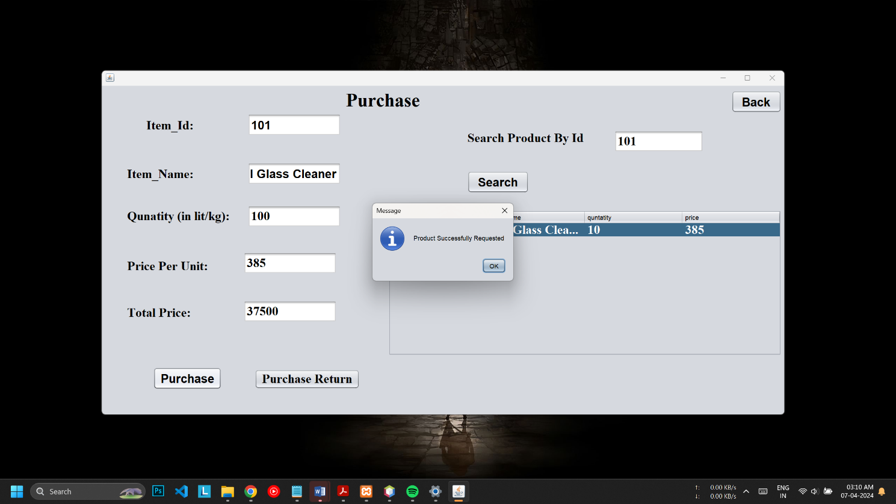

* **Cart Screen**

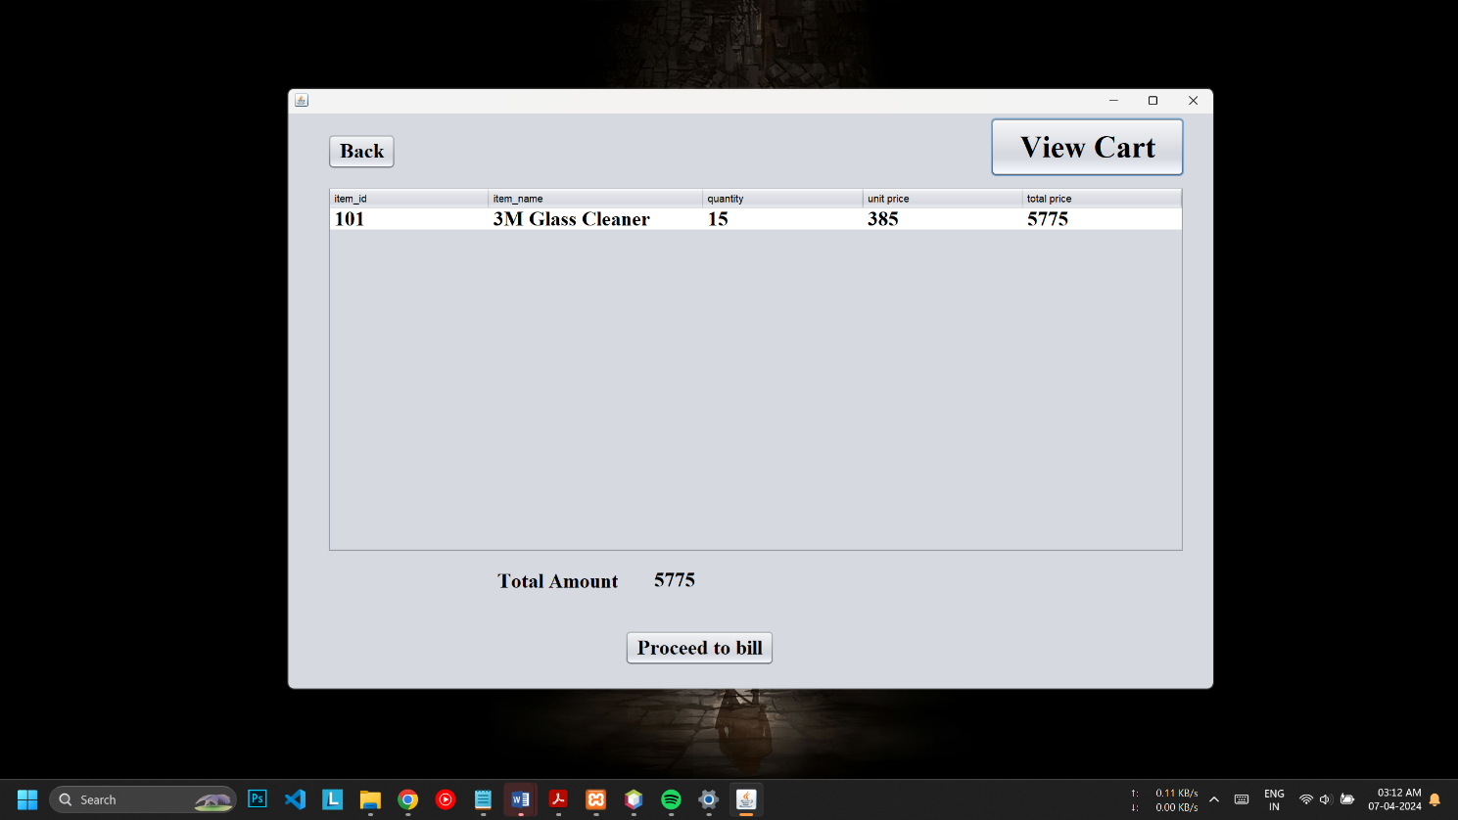

* **Billing Screen**

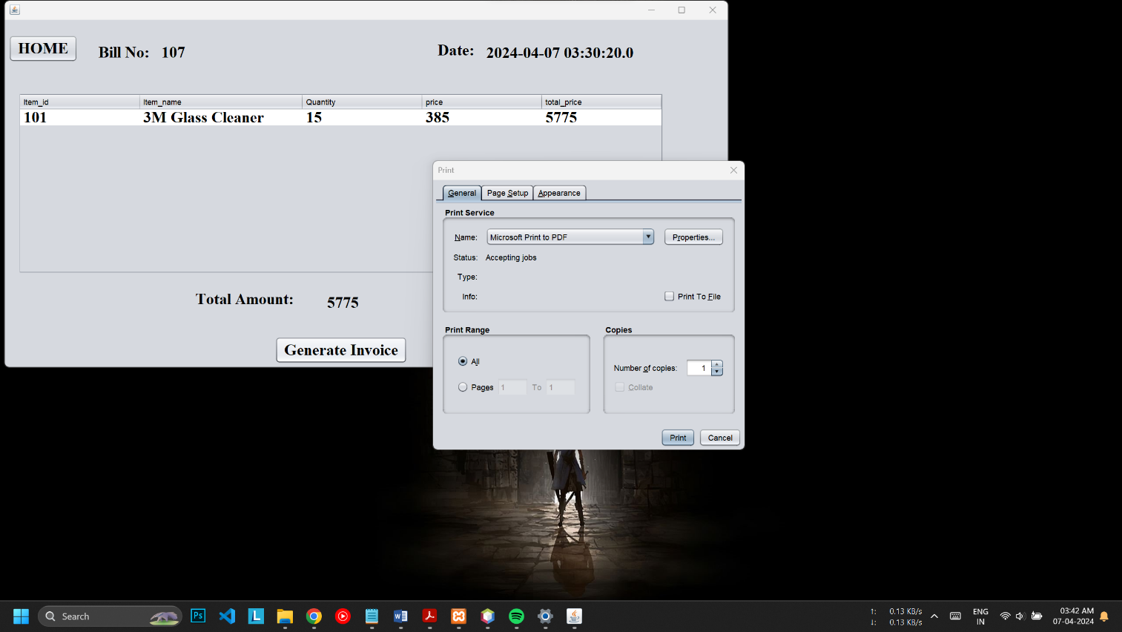

* **Car Wash Screen**

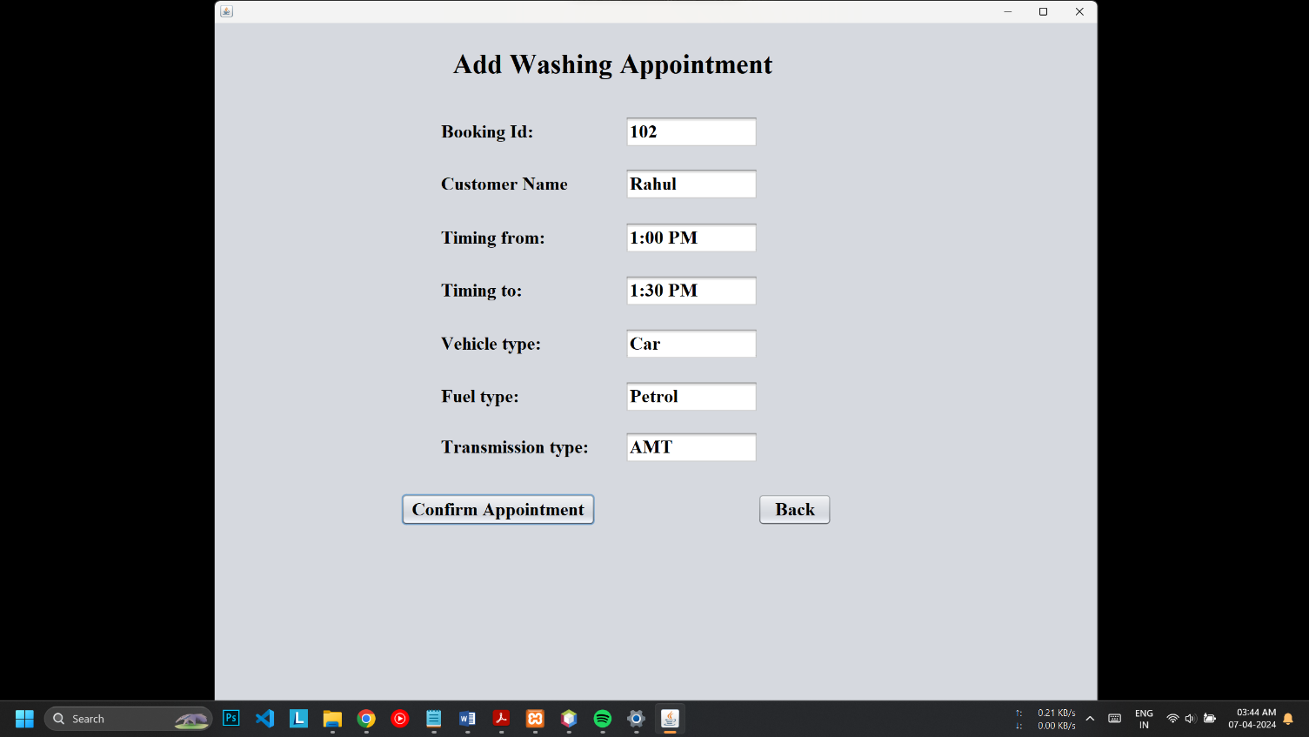

* **Car Wash Data Display**

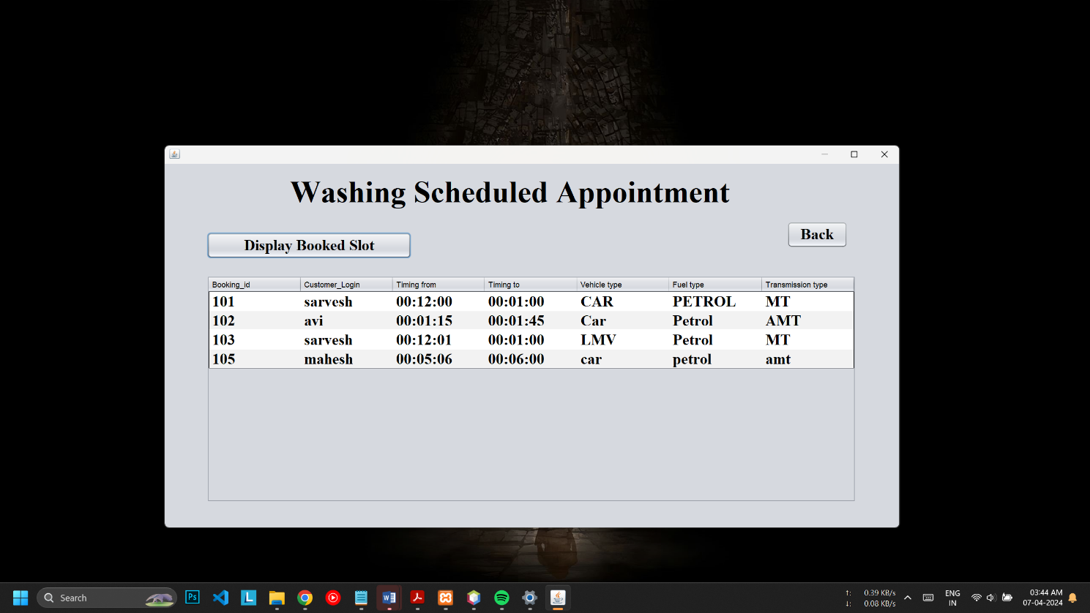

* **Denting/Color Data Entry**

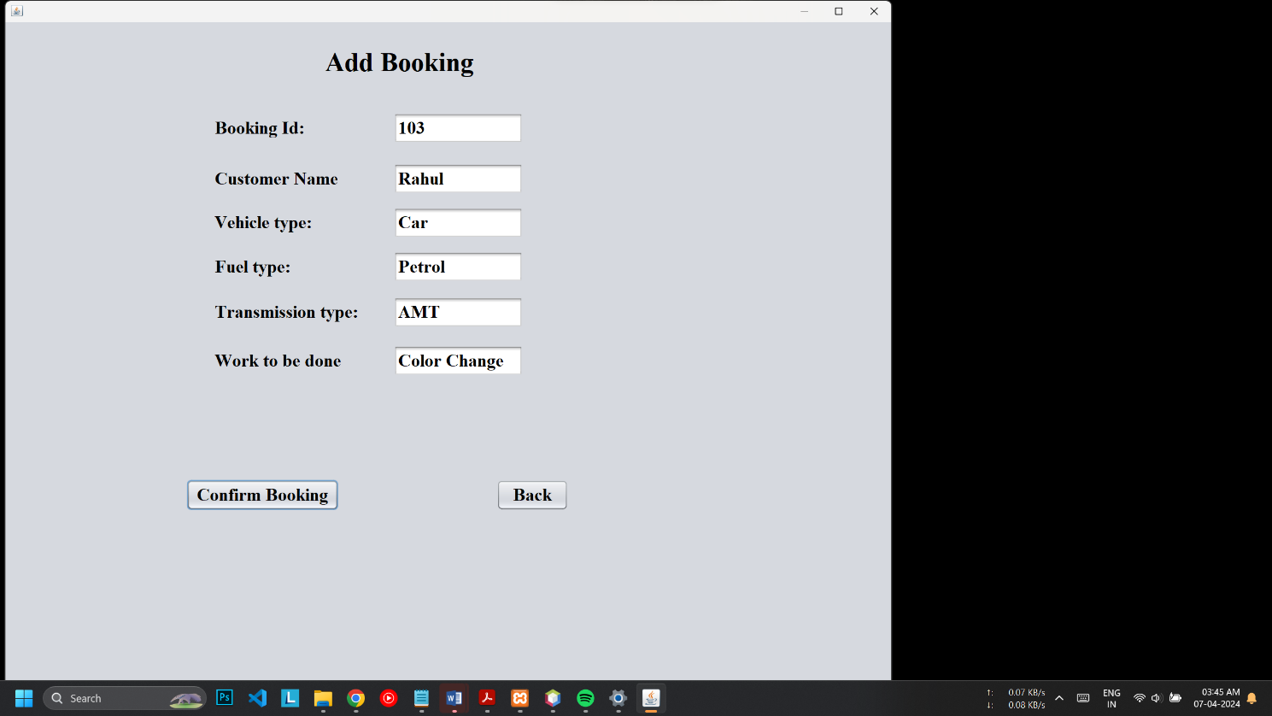

1. **Implementations Details**

* **Hardware & Software Requirement**

1. **Hardware Requirement:-**

Hardware Requirements;

Name of component Specification

Processor Pentium III 630MHz

RAM 2 GB

Hard disk 20 GB

Monitor 15 color monitor

Hardware Requirements;

Name of component Specification

Processor Pentium III 630MHz

RAM 2 GB

Hard disk 20 GB

Monitor 15 color monitor

**Name of Component Specification**

Processor Intel(R) Core(TM) i3-6100U

CPU @2.30GHz 2.30 GHz

Hard disk 200 GB

RAM 2.00GB

System Windows 7/8/10 Operating System(32/64-bits)

1. **Software Requirement:-**

|  |  |
| --- | --- |
| Language | Java |
| Frontend | Swing |
| Database | MySQL |

1. **Outputs and Reports Testing (Test Plan)**
   1. **Data Validation Test Cases (BBT):-**

|  |  |  |  |  |  |  |
| --- | --- | --- | --- | --- | --- | --- |
| **Sr no.** | **Module Name** | **Test Case** | **Test Data** | **Excepted**  **Result** | **Actual**  **Result** | **Status** |
| TC-01 | Login | Verify Home Visibility After Login | Username: admin  Password: 123 | Successful Login Should redirect to homepage | Redirected to Homepage after successful login | Pass |
| TC-02 | Home | Verify that all the button are responsive and functional | - | Button should redirect to their respective component | Buttons were clickable, responsive and functional | Pass |
| TC-03 | Product | Verify entered data in input field | Item_id: 01  Item_name: 3M Glass Cleaner  Quantity: 100  Price: 3300 | User should be able to fill the input field with data | Data was filled seamlessly | Pass |
| TC-04 | Inventory | Verify Product data is visible or not | - | Product data should be displayed | Full detail information about product was visible | Pass |
| TC-05 | Inventory | Verify Product data is visible according to displayed table | - | Product data is properly visible according to their table field | Product were visible successfully according to their field in table | Pass |
| TC-06 | Inventory | Verify Data is arranged in order | - | Product data is displayed in certain order | Product data is visible according to date created | Pass |
| TC-07 | Update | Verify Product Data is successfully updated | Quantity: 100 | Product data is updated successfully all over system | Product Data was successfully updated | Pass |
| TC-08 | Update | Notification on successful updation | - | To receive success notification on updation | Received success notification after successful updation of product | Pass |
| TC-09 | Update | Verify Changes are made to database | - | Immediate updation of product details in database | Product data was updated effectively in database | Pass |
| TC-10 | Purchase | Verify whether Selected Product is successfully added to cart | Item_id : 01 | Right Product get added to cart | Only Selected product is added to cart for purchase | Pass |
| TC-11 | Purchase | Verify whether Total Price is calculated | Quantity: 100  Price: 3300 | Total Price gets automatically calculated | Total price is calculated Corrected | Pass |
| TC-12 | Purchase | Verify click on add to cart button adds product int cart | - | Product should be added to cart | Product got added to cart successful | Pass |
| TC-13 | Cart | Verify Bill get generated by Clicking | - | Bill get generated successfully with proper order data | Bill was generated properly with all order details | Pass |

* 1. **White Box Testing:-**

In white box testing knowing the internal working of the product, tests can be conducted to ensure that internal operations are performed according to specification and all internal components have been adequately exercised. In white box testing logical path through the software are tested by providing test cases that exercise specific sets of conditions and loops. Using white-box testing software developer can derive test case that

• Guarantee that all independent paths within a module have been exercised at least once.

• Exercise all logical decisions on their true and false side.

• Exercise all loops at their boundaries and within their operational bound.

• Exercise internal data structure to ensure their validity.

At every stage of project development I have tested the logics of the program by supplying the invalid inputs and generating the respective error messages. All the loops and conditional statements are tested to the boundary conditions and validated properly.

1. **Conclusion**

The Body Shop Management System is developed and designed for recording and managing the inventory of an organization. It can also be used for different institution with fewer modification as per requirement. the system can be easily updated as the other institutional requirement may not be integrated on our project . After the continuous effort , testing and debugging the current system is ready to be implemented in an organization.

Some of the lesson that we had learned from the project are:-

* Sharpen the knowledge of working cooperating in working organizational environment and work place.
* Know the value of time and disciple.
* Work in group and make group decision.
* Learnt communication skill, leadership , quality and to make good public relation.

**6.1 Limitations**

* This application does not have a built in check out process.
* An external checkout package has to be integrated in to this application. Also users cannot save the shopping carts so that they can access later i.e. they cannot create wish lists which they can access later.

* This application does not have features by which user can set price ranges for products and receive alerts once the price reaches the particular range.
* Internet access required: When participating, for being able to buy and sell, you need a device connected to the internet. Currently, most people have internet access but, in many areas, it is still very limited

1. **Future Enhancement**

Future enhancements for an Body Shop Management System (BSMS) can incorporate advancements in technology, address evolving business needs, and improve user experience. Here are some potential future enhancements:

1. **Enhanced Mobile Capabilities:**
   * Develop mobile applications with advanced functionalities for body shop management tasks such as barcode scanning, receiving, picking, and shipping. Mobile-enabled BSMS can provide on-the-go access to inventory data and streamline operations for field personnel.
2. **Customizable Dashboards and Reporting Tools:**
   * Enhance the BSMS with customizable dashboards and reporting tools that allow users to visualize key inventory metrics, track performance KPIs, and generate ad-hoc reports. Customizable reporting capabilities can provide actionable insights for informed decision-making.
3. **Cloud-Based Deployment and Scalability:**
   * Offer cloud-based deployment options for the BSMS to provide scalability, flexibility, and accessibility across distributed locations. Cloud-enabled BSMS can support growing inventory volumes, expanding business operations, and remote workforce collaboration.

By incorporating these future enhancements, an Body Shop Management System can stay ahead of the curve, adapt to changing business requirements, and continue to deliver value in an increasingly dynamic and competitive marketplace.

**8. Bibliography**

* James Gosling. Java (Programming Language)

Available from: http://www.java.com

* Names Allaire, Netbeans-Fully-featured Java IDE,

Available from: <https://www.w3schools.com/php>

* Greeks Of Geeks

Available from : <https://www.geeksforgeeks.org/java-tutorial/>

* Youtube (Java Tutorials)

Available from: <https://youtu.be/HfSQL2H7_mE?si=D_gL07C1rHKsB_BZ>

* Smart Draw (for drawing all the Diagrams used in this report)

Available from: <https://www.smartdraw.com/>